아시아경제공동체재단 청년위원회 AECF Youth Commission |  |  |  |  | 문의 | aecfyouthcommittee7@gmail.com
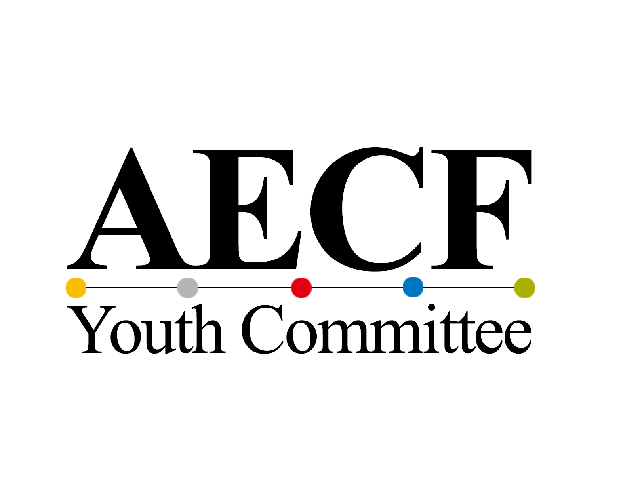 |  |  | MAU PROPOSAL

The Model Asia Union (MAU) is an international academic competition aimed at bringing together students from all over the globe to discuss issues related to Asian regional cooperation. Participation in the MAU encourages participants to engage with topics such as Asia's regional cooperation, the formation of an economic community, and the general developmental track that Asia should pursue. The 15th MAU is a competition based on paper-writing and presentations, hence requiring creativity, cooperation, and leadership.

□ About this year's theme
- APEC 2.0: Prospects for Future Strategies of Asia Economic Community Amidst US-China Competition

□ Eligible Participants
- All undergraduate and graduate students who are interested in Asian diplomacy and economics
- Individuals who are willing to participate actively in the program
- 1 individual or a team of up to 3 candidates
- Individuals who can participate in all English-language programs

□ Recruitment Schedule
- MAU Application Deadline (Preliminary Round): September 19, 2023 (23:59 KST)
- Finalists Announced: September 27, 2023
- Final Paper Submission Deadline: October 29, 2023
- MAU Final: November 2-3, 2023

□ About submission
- Please submit a presentation video lasting 7 to 8 minutes with this proposal.
- The focus of the presentation video should be on the content you intend to deliver during the MAU forum on the scheduled day based on your proposal provided below.
- In visual materials (presentation materials such as PowerPoint slides), logical coherence takes precedence over design aesthetics.
- Your video should include your face, voice, and physical gestures. (*All team participants must participate in the presentation.)

□ Activity Schedule
- November 2nd and 3rd, 2023

□ Due date for the qualification stage
- Submissions should be sent to aecfyouthcommittee7@gmail.com by 23:59 on Saturday, September 23rd.

□ Email / File Title Form for the qualification stage
- Applicant Name_MAU

□ Points to Note
- Qualified candidates must participate in the MAU with prepared presentations and papers on the designated day.
- Students on leave of absence are also eligible to participate in the event.
- Students should aim to craft a persuasive paper that contains your distinctive viewpoints and well-structured logical opinions.

□ Benefits of Participation
- All finalists will be given a one-day stay during the MAU
- Participation certificates will be issued to all finalists
- All finalists will be given the opportunity to participate in various programs of the Asia Economic Community Forum in addition to the MAU to broaden their views and views on the Asian economy

□ Award
· 1st place – Chairman of the Ban Ki-moon Center for Global Citizens Award, AirPods
· 2nd place - Incheon National University President's Award
· 3rd place – Chairman of the Asia Economic Community Foundation Award

□ Contact Info
- aecfyouthcommittee7@gmail.com
- KakaoTalk: aecf

Submission document 1 | Application Form

Title of proposal
Team name
* Not required
Participant 1  (Representative) | Name |  | Date of Birth
Participant 1  (Representative) | Phone |  | E-Mail
Participant 1  (Representative) | Affiliation
Participant 2  (Optional) | Name |  | Date of Birth
Participant 2  (Optional) | Phone |  | E-Mail
Participant 2  (Optional) | Affiliation
Participant 3  (Optional) | Name |  | Date of Birth
Participant 3  (Optional) | Phone |  | E-Mail
Participant 3  (Optional) | Affiliation
Precautions for writing | * Please ensure that you provide your legal name when filling out your personal information.  * If submitting as a team, include both the team name and the names of all team members. Please double-check for any omissions in the list of team members.
[개인정보 수집 및 이용 제공 동의]

수집 내용: 성명, 소속, 전화번호, 이메일, 생년월일 등
수집 목적: MAU 모집 진행을 위한 개인정보
수집 이용 기간: MAU 행사 이후 개인정보 즉시 파기

* 활동자의 경우 합격 안내를 위한 용도로 이용되며, MAU 진행 후 파기됩니다.
본인은 위 사항을 확인 후 이해하였으며 개인정보 수집 및 이용에 동의합니다.

예 □ 아니오 □

Submission document 2 | MAU PROPOSAL

Title
Table of Contents for paper
Problem Statement
[Background, Introduction]
Paper
Abstract

[Research directions, plans, details and expectations you'd like to study]
Expected Conclusions and Suggestions
Reference
* optional

※ Write your proposal on 3 to 5 pages (We ask you to use 10-point font for your proposal. Do not use double space in the states.)

